**Company:** Can-Fil Contracting Ltd.

**Address:** 22005 98A Ave NW

Edmonton, AB, T5T 4M3

**Contact Info:**

1. Phone#587-340-0195

Email: [canfilcontracting@gmail.com](mailto:canfilcontracting@gmail.com)

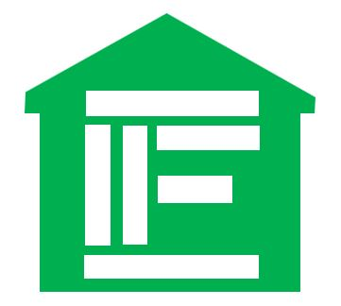

**Logo:**

**CAN-FIL CONTRACTING**

Care. Quality. Satisfaction.

**Company history:** The story of Can-Fil Contracting began with a couple’s dream of simply being able to spend more time with their family especially their growing children. Francis and Notwesa are a couple who migrated to Canada from the Philippines in 2016 in hopes of securing a more stable future for their young family. Fortunately, with the help of friends and through their passion, both were able to secure jobs in just a few months after landing in the country. However, since the effect of the economy’s recession from the previous years remain remarkable and despite working hard and staying dedicated, Francis experienced being laid off from the jobs he got and while Notwesa did the same kind of job since 2016, both felt that there is something more that they wanted to do besides being regular employees who could become dispensable in times of crisis. Hence, after many nights of brainstorming and asking for God’s guidance and wisdom in the midst of the COVID-19 Pandemic, they came to realize that their passion for providing paramount service in terms of construction and innovation would not only give realization to their desire but could also bring satisfaction to clientele and be a way of contributing to the economy of the place they now call HOME.

**Mission:** Our mission is to deliver excellent customer service performed safely to every single project we do, to meet if not to exceed our client’s expectation and satisfaction.

**Vision:** To build and maintain a reputable renovation and construction company; enjoy what we do while providing quality service that exceeds our client’s expectation and take pride by leaving our costumer happy.

**Scope of work:** Ensuring customer satisfaction is our mission; hence, we at Can-Fil Contracting takes pride in doing any kind of Interior and Exterior Renovation, Deck & Fence, Garage Construction.

**Our Qualifications:**

Fully insured

Comprehensive criminal background checks